Q1:

ALTER TABLE project ADD PRIMARY KEY(‘P_No’);

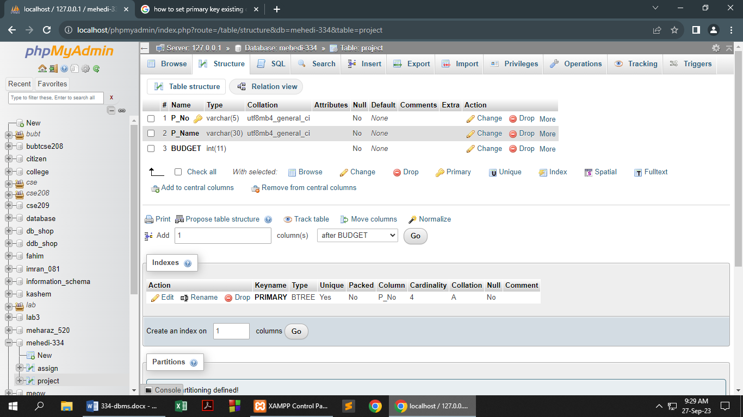

[ALTER](http://localhost/phpmyadmin/url.php?url=https://dev.mysql.com/doc/refman/8.0/en/alter-table.html) [TABLE](http://localhost/phpmyadmin/url.php?url=https://dev.mysql.com/doc/refman/8.0/en/alter-table.html) assign ADD PRIMARY KEY(`EMP_ID`);

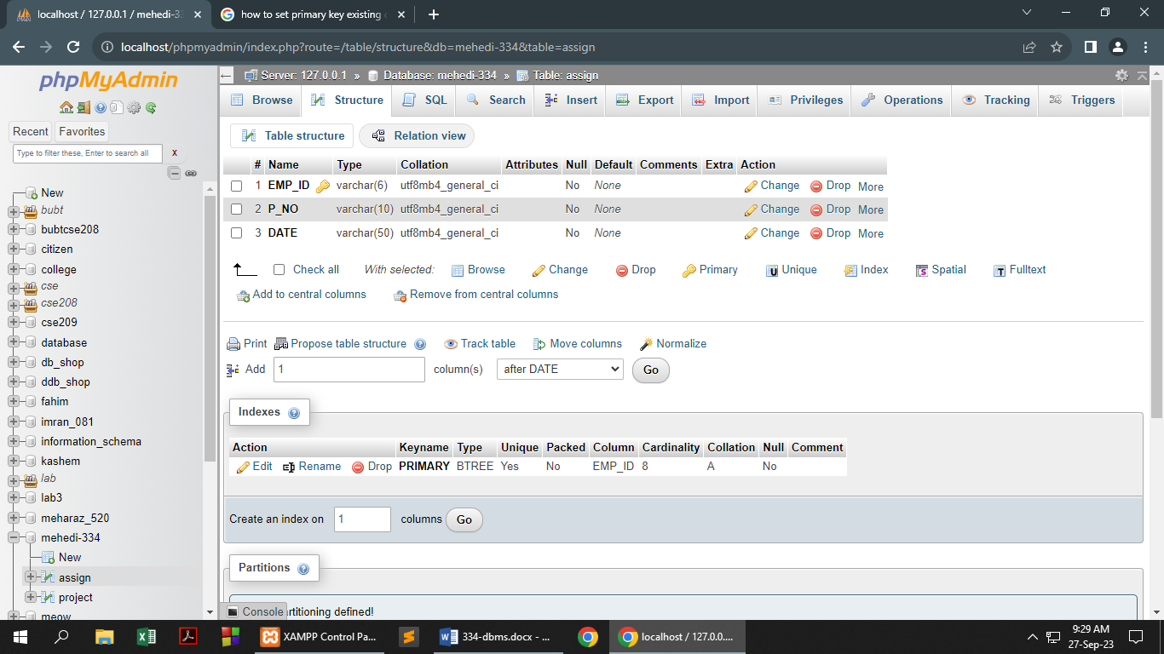

Q2:

[SELECT](http://localhost/phpmyadmin/url.php?url=https://dev.mysql.com/doc/refman/8.0/en/select.html) SUBSTR(EMP_ID,length(EMP_ID)-1,2)"Last two charachter" FROM assign;

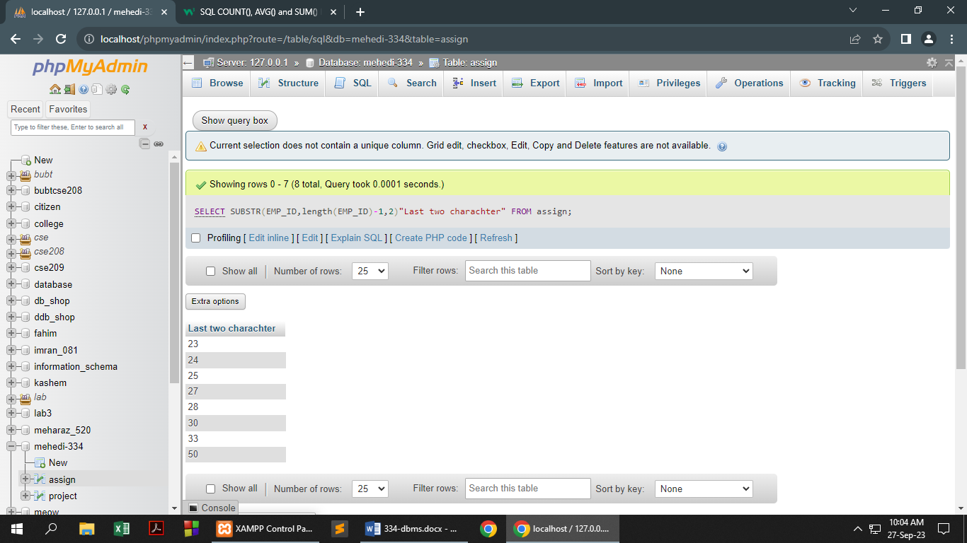

Q3:

[SELECT](http://localhost/phpmyadmin/url.php?url=https://dev.mysql.com/doc/refman/8.0/en/select.html) P_Name FROM assign NATURAL JOIN project WHERE DATE [LIKE](http://localhost/phpmyadmin/url.php?url=https://dev.mysql.com/doc/refman/8.0/en/string-comparison-functions.html%23operator_like) '%%%%%May%%%%%';

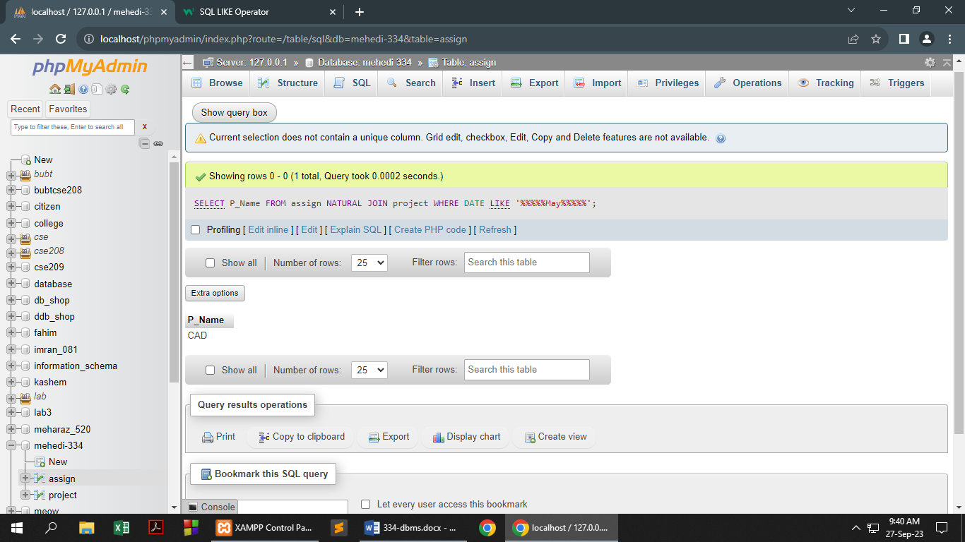

SELECT P_Name FROM assign CROSS JOIN project WHERE project.P_No=assign.P_NO AND DATE LIKE '%%%%%May%%%%%';

Q4:

[SELECT](http://localhost/phpmyadmin/url.php?url=https://dev.mysql.com/doc/refman/8.0/en/select.html) [SUM](http://localhost/phpmyadmin/url.php?url=https://dev.mysql.com/doc/refman/8.0/en/aggregate-functions.html%23function_sum)(BUDGET) FROM project WHERE BUDGET>"200000";

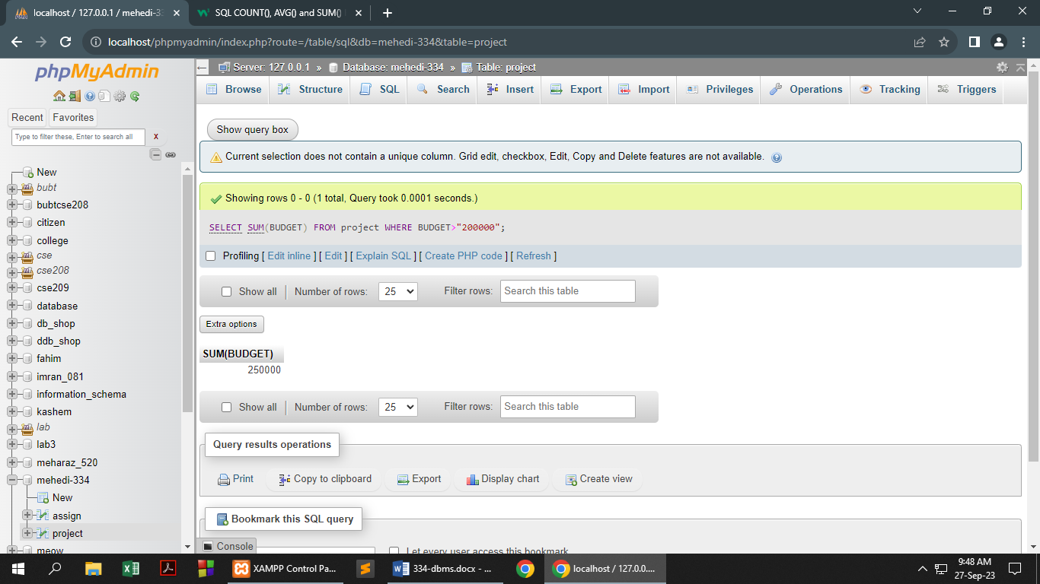

Q5:

[SELECT](http://localhost/phpmyadmin/url.php?url=https://dev.mysql.com/doc/refman/8.0/en/select.html) P_Name,BUDGET*1.02 FROM project WHERE P_Name="CAD";

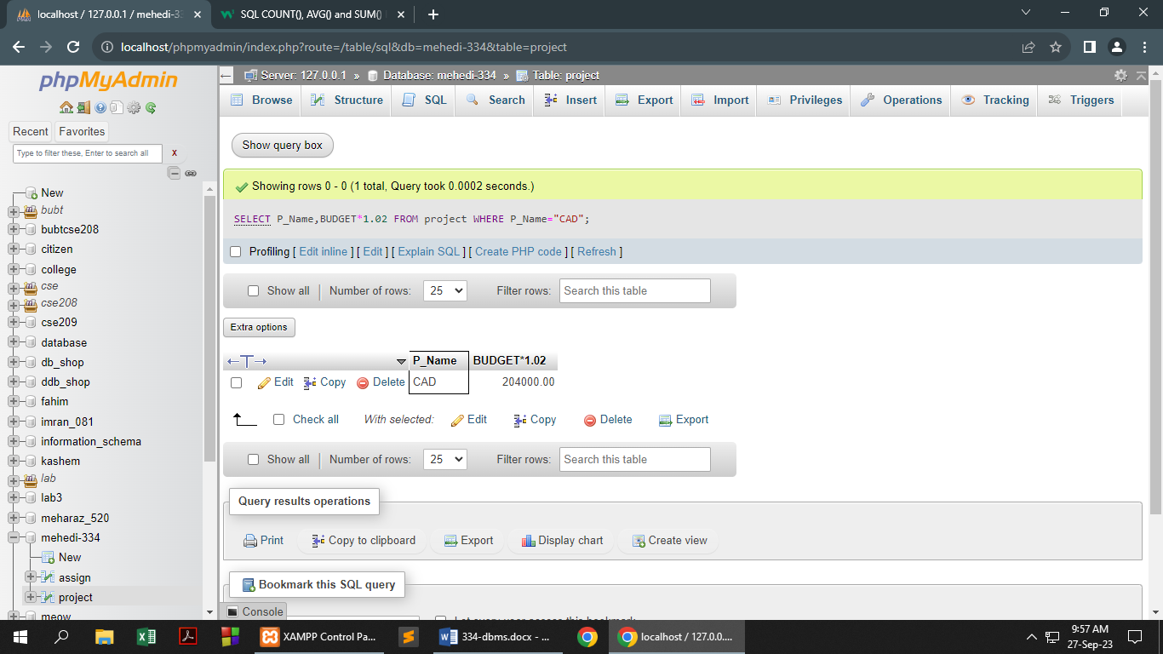

Q6:

[SELECT](http://localhost/phpmyadmin/url.php?url=https://dev.mysql.com/doc/refman/8.0/en/select.html) EMP_ID FROM assign WHERE EMP_ID [LIKE](http://localhost/phpmyadmin/url.php?url=https://dev.mysql.com/doc/refman/8.0/en/string-comparison-functions.html%23operator_like) '%00';

